 | Assignment # 1  Semester: FALL 2021  PHYSICS (PHY101) | Total Marks: 20  Due Date:  10 December, 2021

Objective:
The assignment has been designed to enhance your knowledge and understanding of Physics & and their applications in your daily life.
Instructions:
Please read the following instructions carefully before solving & submitting assignment:
- To solve this assignment, you should have good command over first 12 lectures.
- Do not rely only on handouts but watch the course video lectures and read additional material available online
- The assignment will not be accepted after due date. Zero marks will be awarded to the assignment that does not open or the file is corrupt.
- The assignment file must be an MS word (.doc) file format; Assignment will not be accepted in any other format.
- Use Math Type or Equation Editor etc for mathematical symbols.
- Zero marks will be awarded to the assignment if copied (from other student or copied from hand-outs or internet).
- Don’t wait for the last date to submit your assignment.
Write to the point unnecessary explanation will decrease you grades.
For any query about the assignment, contact only phy101@vu.edu.pk
Do not post queries related to assignment on MDB.

««««««««««««««««««««««««Good Luck»»»»»»»»»»»»»»»»»»»»»»
Question No. 1 Marks = = 5 +5 +2 = 12
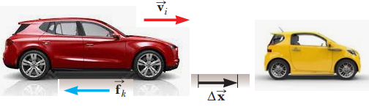
The driver of a 2.0 × 10³ kg red car traveling on the highway at 45m/s slams on his brakes to avoid striking a second yellow car in front of him, which had come to rest because of blocking ahead as shown in above Fig. After the brakes are applied, a constant friction force of 7.5 × 10³ N acts on the car. Ignore air resistance.
(a) Determine the least distance should the brakes be applied to avoid a collision with the other vehicle?
(b) If the distance between the vehicles is initially only 40.0 m, at what speed would the collision occur?
(c) Write your conclusive observations on the result obtained from this numerical. i.e. the importance of Physics in daily life.

Question No. 2 Marks = 8
Consider an automobile moving at v mph that skids d feet after its brakes lock. Calculate how far it would skid if it was moving at 2v and the brakes were locked.

Best of luck

